* Project Name – **SUSTAINABLE SUPPLY CHAIN USING PERFORMANCE Dashboard Using Power BI**
* In this i had sorted the huge table to small, small tables for better understanding and to do Analysis of Data Neatly.
* Tables Like

1.Inventory Table

2.Manufacturing Table

3.Supplier Table

4.Supply Chain Table.

1.Inventory Table

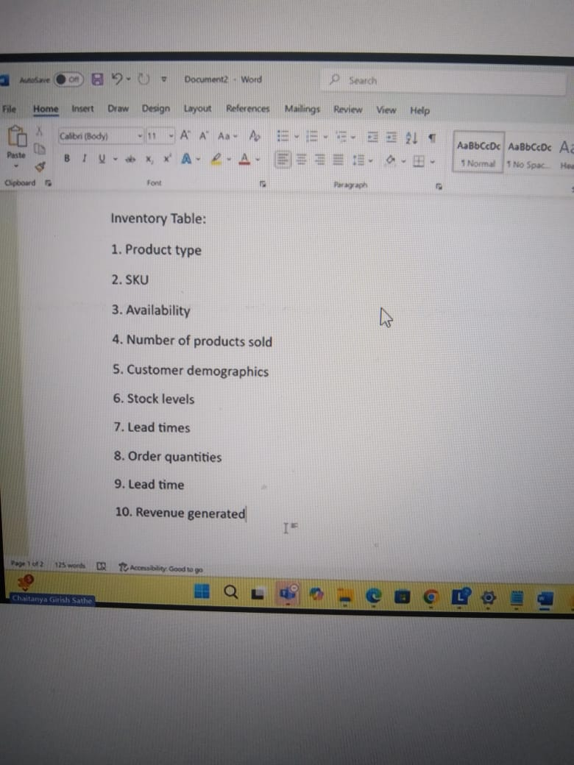

2.Manufacturing Table

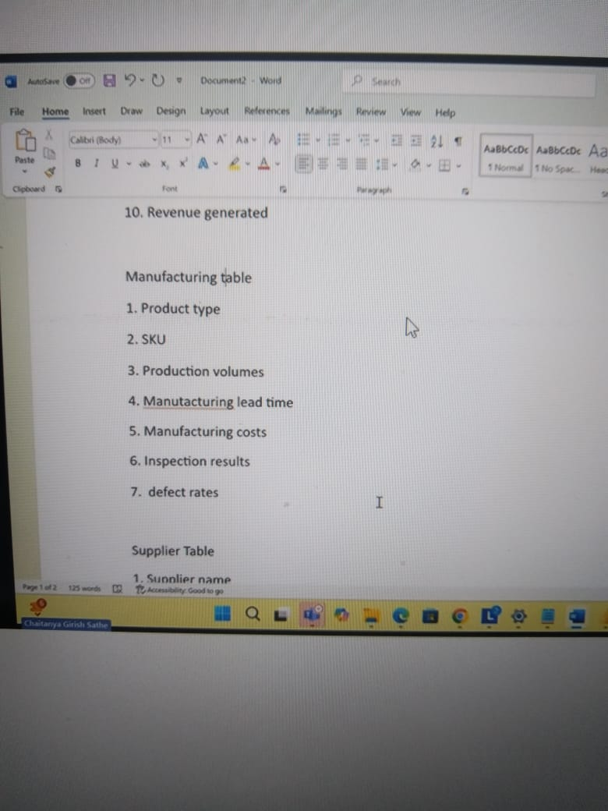

3. Supplier Table

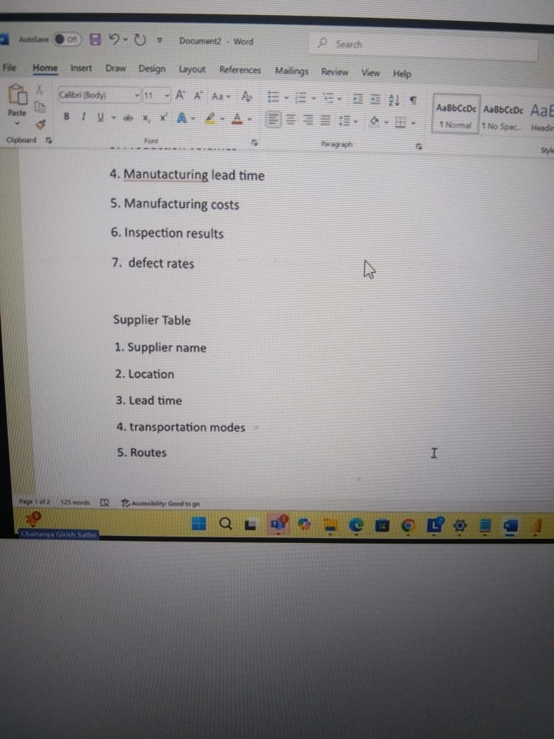

4.Supply Chain Table

